**LAB-6**

**Express CRUD API for Customers data**

**Introduction:**

In this lab we are going to create basic CRUD functions which would Add, List, Read, Remove, Update Customers data in Node JS by calling them from the command line using express framework.

**Objective:**

* To create a CRUD API for storing customers data with fields such as customer First Name, Last Name, Id, Phone, Email and creating functions to add, list, read, remove and update the data.
* To perform the lab using Yargs Module
* Using Express framework to call functions from command line.

**Implementation:**

1. Having NodeJs installed is a prerequisite.
2. Next a directory and a package is created with npm init command where later the express framework, fs, yargs and lodash modules are installed using the commands shown.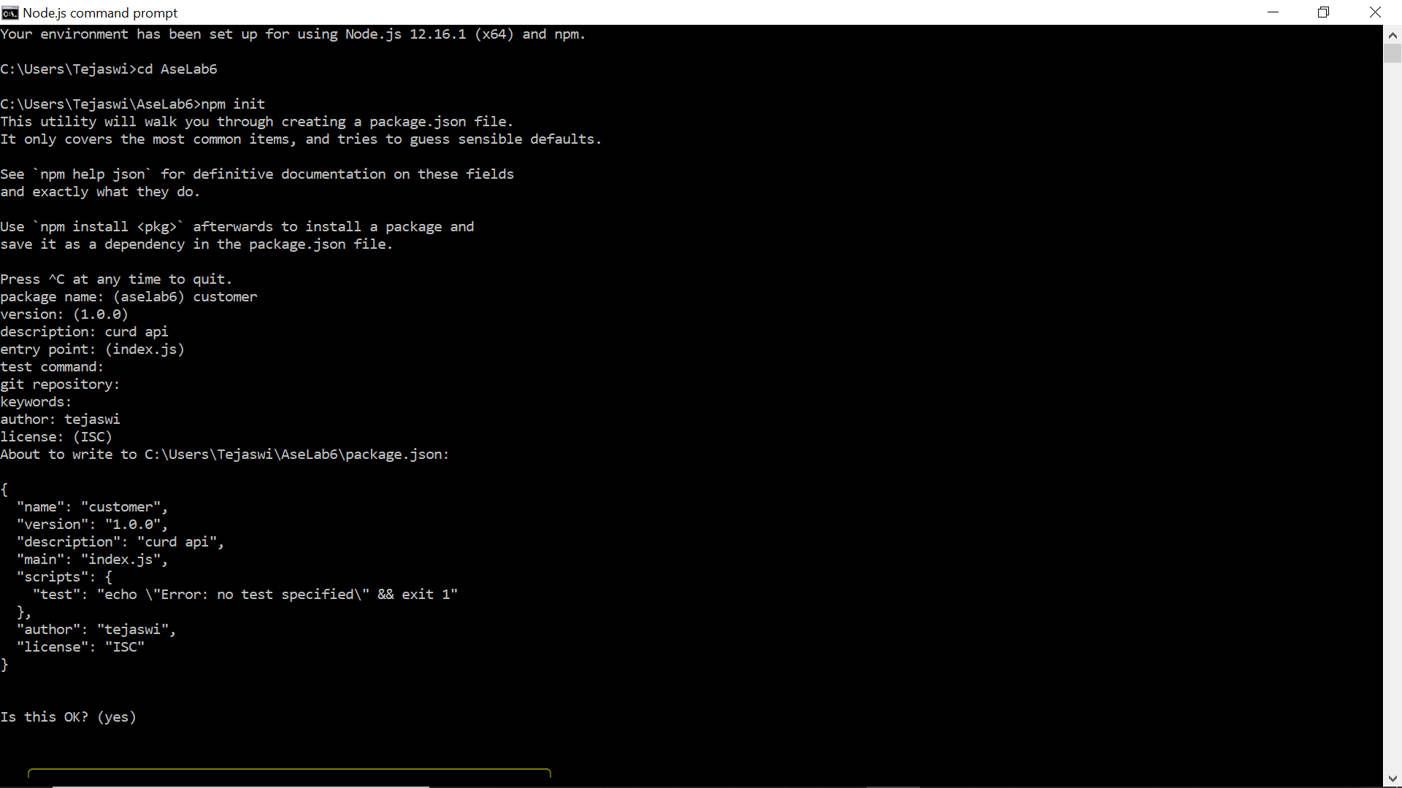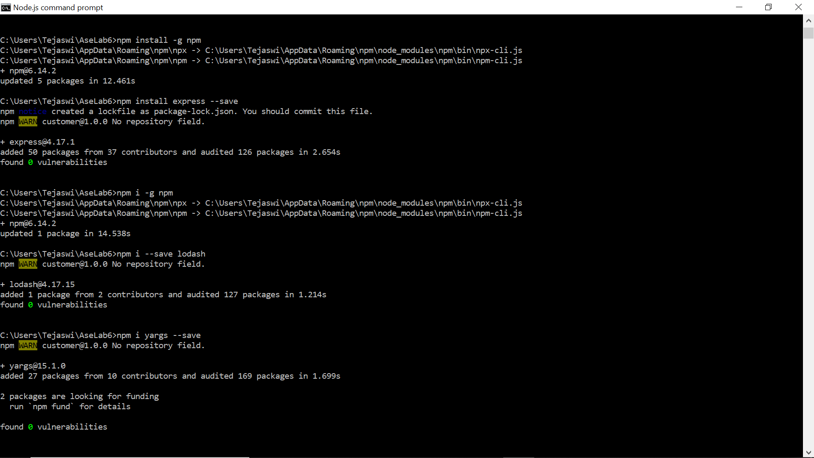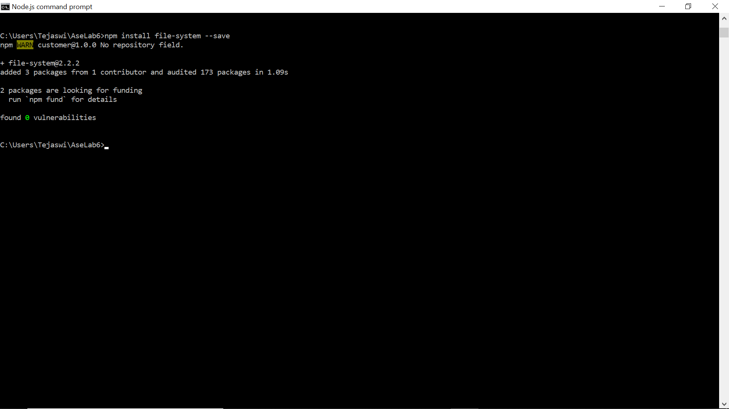
3. Created a custdata.js file where the utility functions fetchNode and saveNode functions that use the fs module use the customer-data.json are written.
4. The functions that add, list, read, remove, update customer data are implemented in this js file.
5. We use the addNode fuction to add customer and store the first name, alst name, id, phone and email. The getAll function is used for listing all the saved customer details. The getNode function is used for fetching customer data using Id. The removeNode function also uses the Id to remove a customer. Lastly, updateNode function uses all the fields to update information.

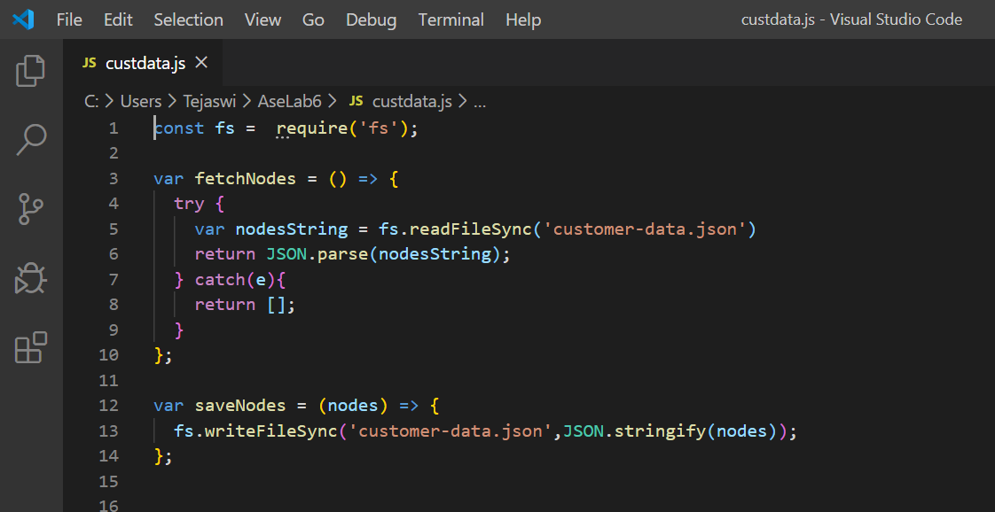

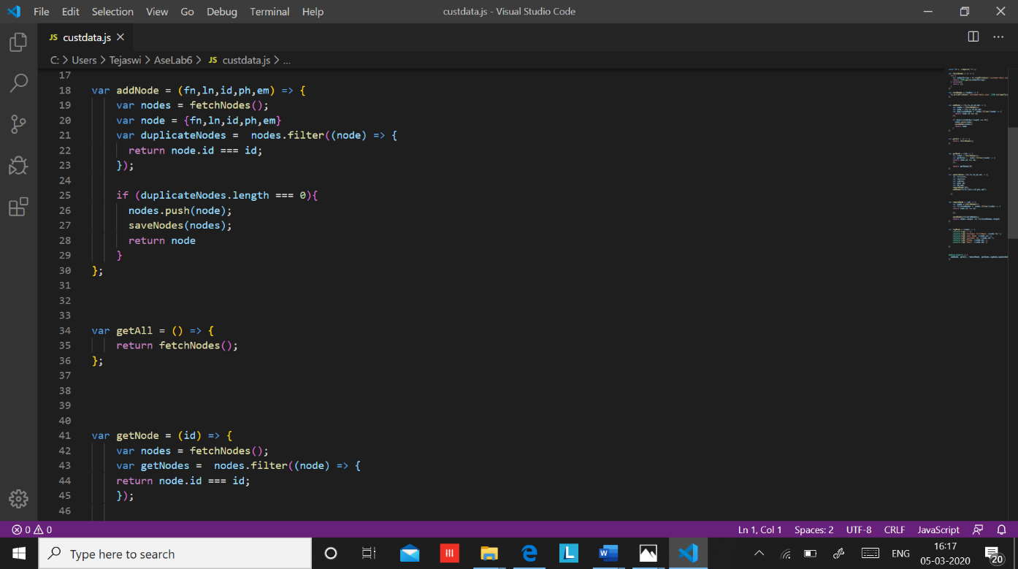

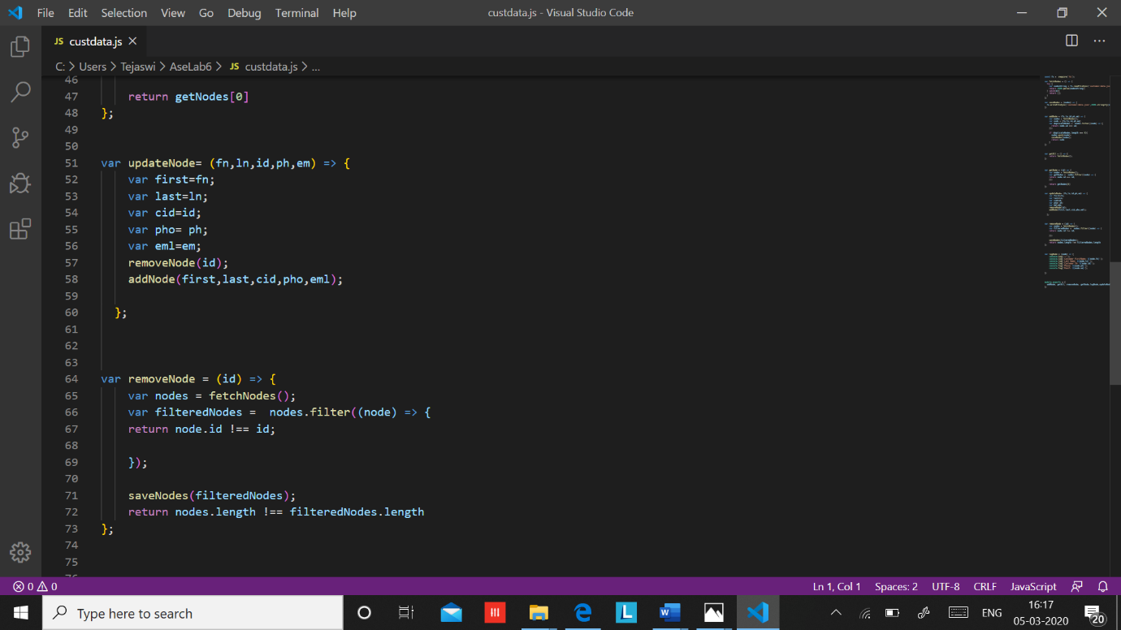

1. Next we created a customer.js file. Imported the fs and the yargs module for enabling the command line interface and imported the custdata.js file to implement the curd function.

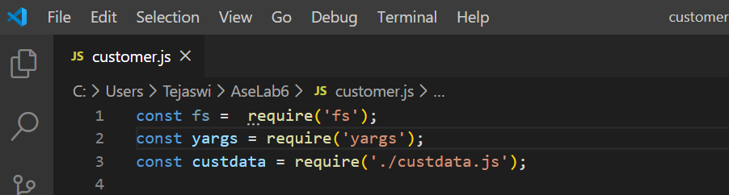

1. Created command line configuration for Customer’s first name, last name, id, phone, email.

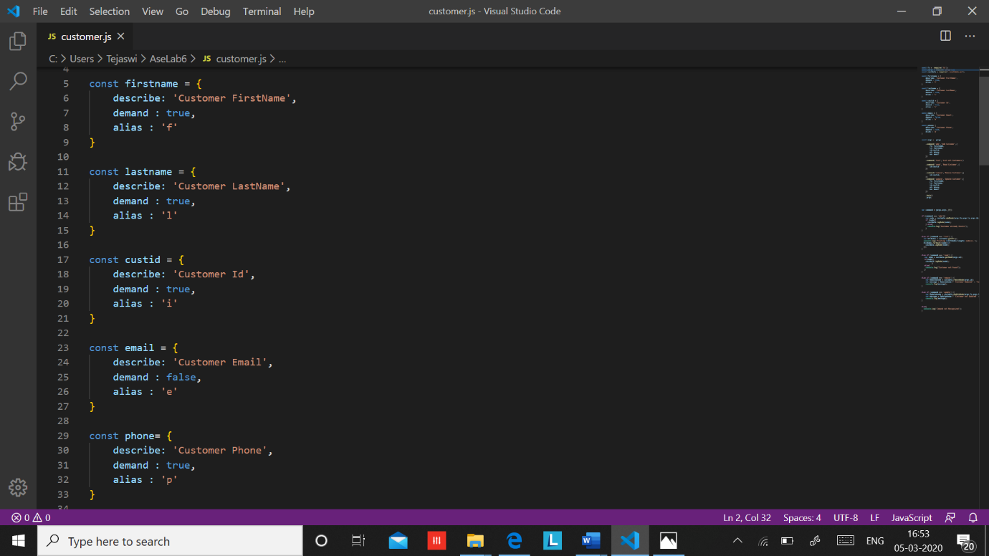

1. Configured list of commands like add, list, read, remove and update.

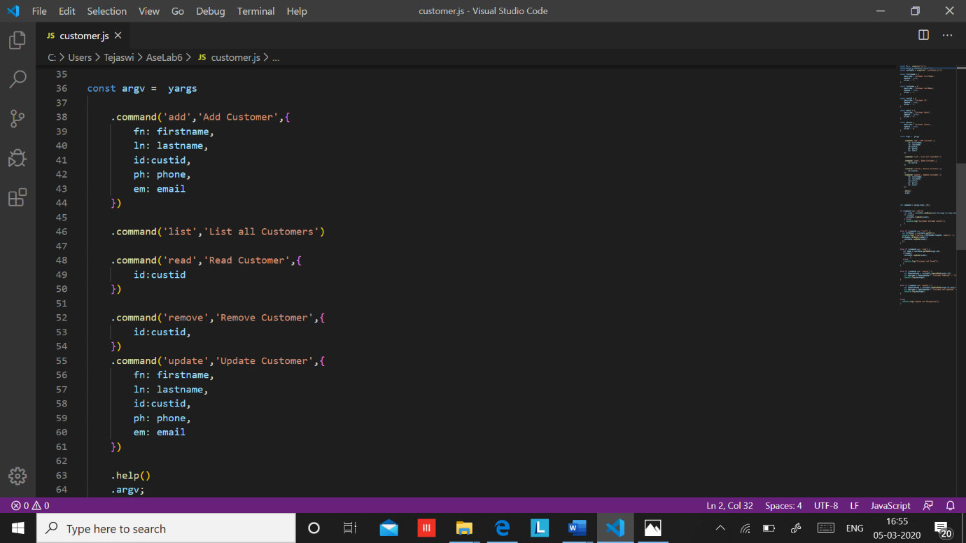

1. Implemented all the above-mentioned function execution that uses and manipulates the data in the json format.

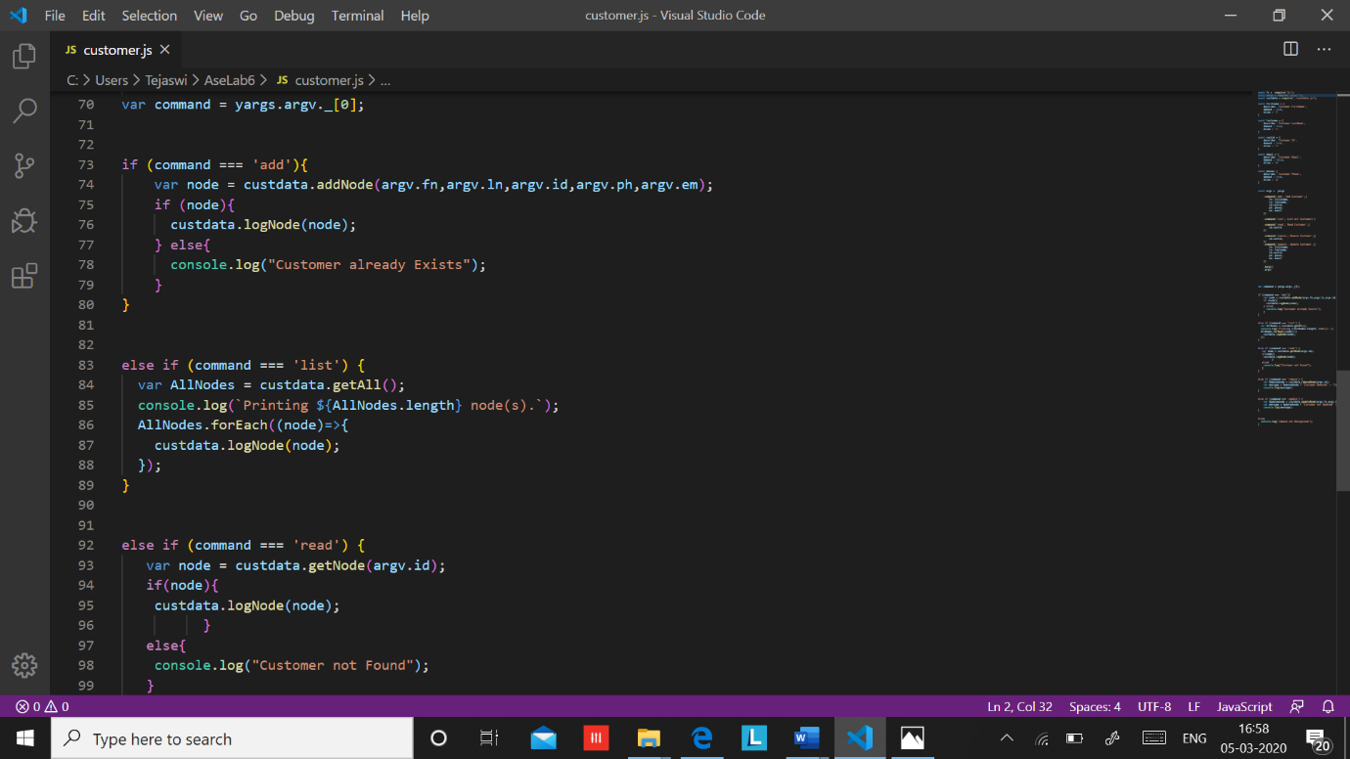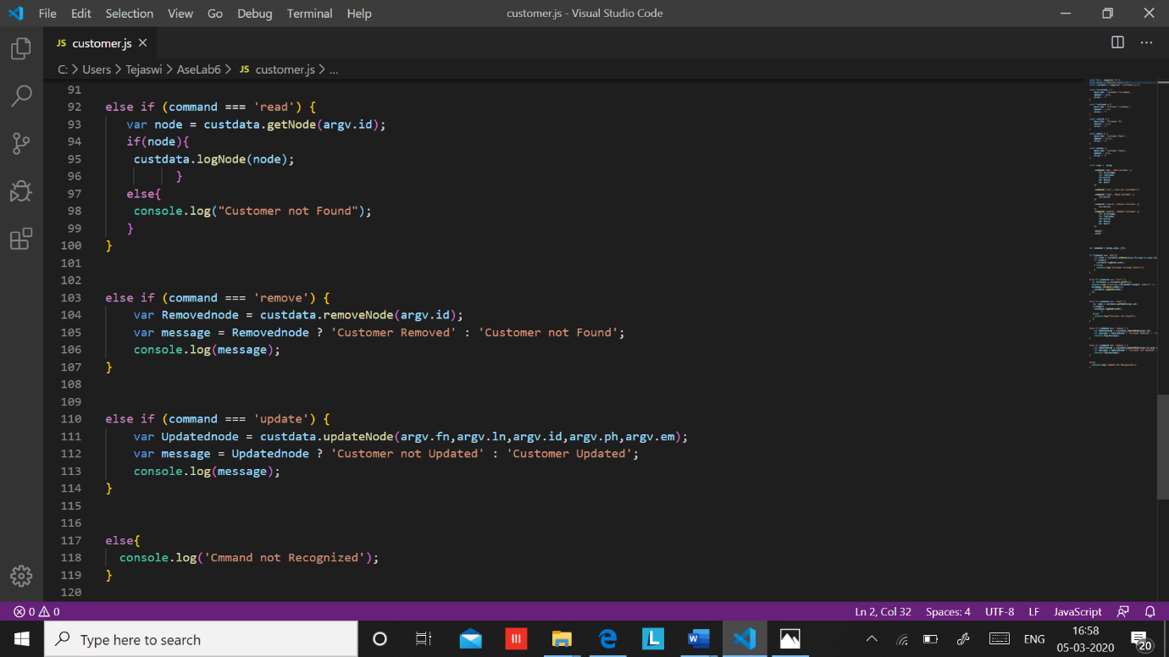

**Outputs:**

1. Add:

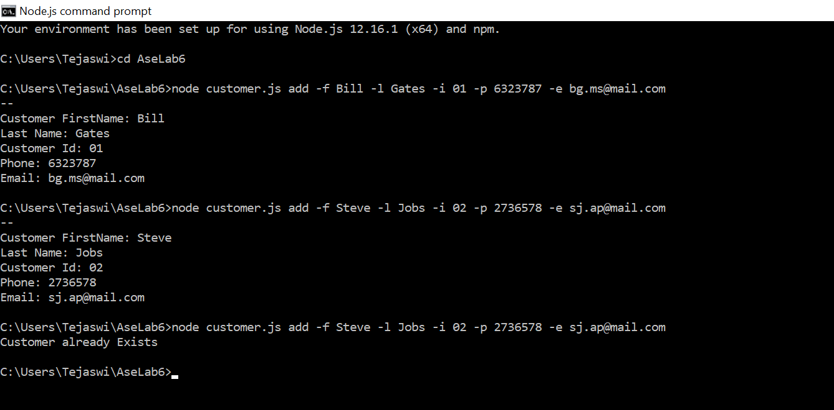

2. List:

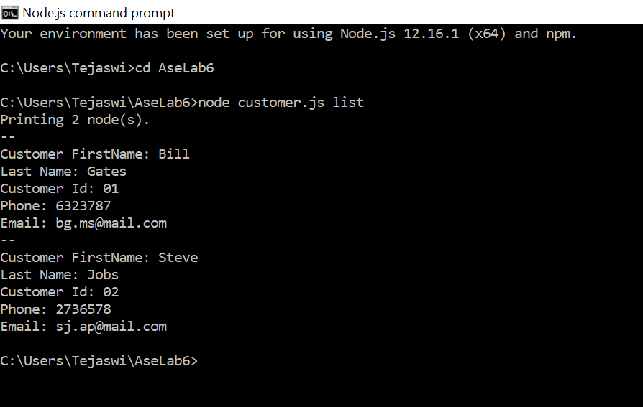

3. Read:

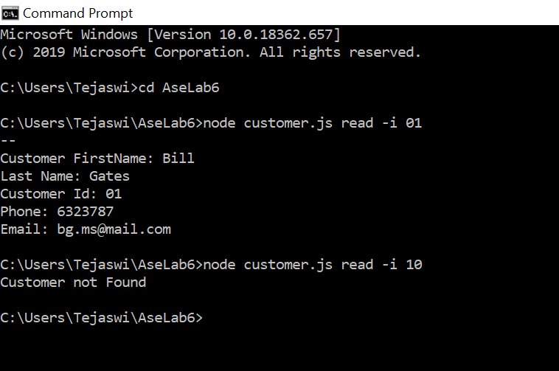

4. Update:

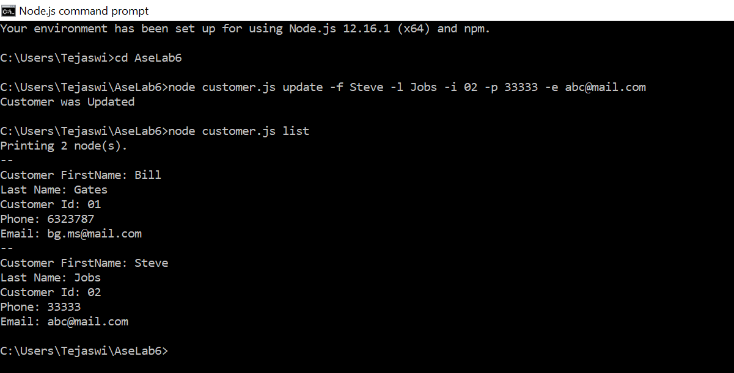

5. Remove:

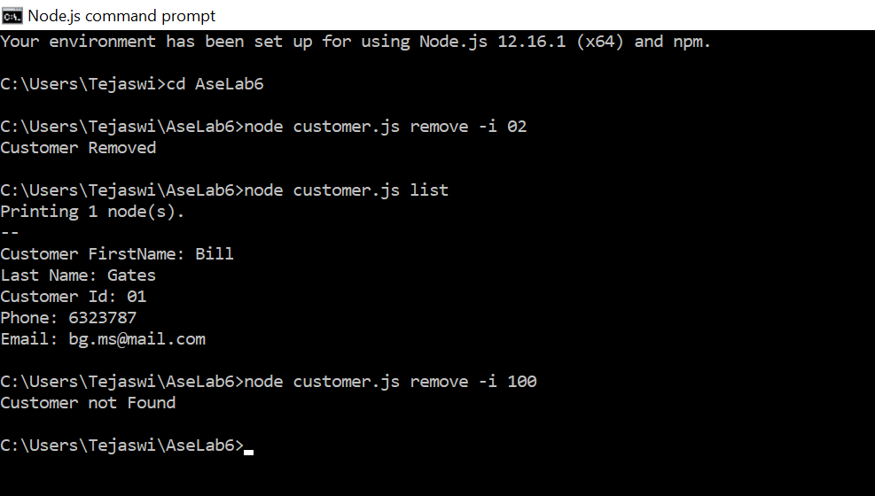

**Conclusion:**

In this assignment, we have learned how Crud Api can be handled using express and nodejs.

**Done By**:

Name class Id

Karishma Yallanki 29

Tejaswi Guturu 16